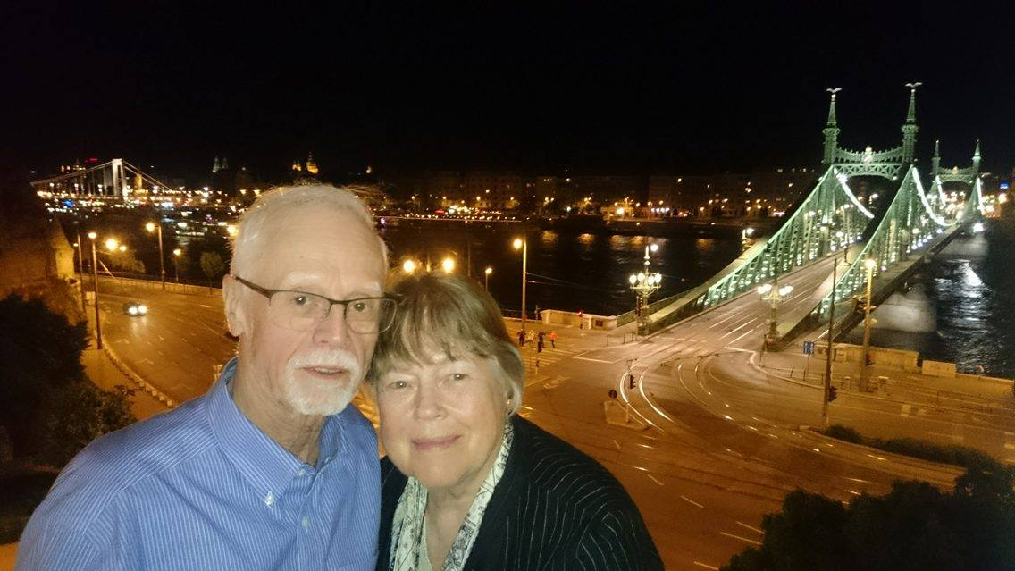
Ruth Sandor – APLIC-I member from Wisconsin 1970-
Ruth Sandor in May 2016 at the Gellert Hotel, Budapest with her husband Sandi

In 1970 I was hired as the first professional information specialist at the Center for Demography, Department of Sociology, at the University of Wisconsin-Madison. The Director of the Center told me there was an organization of other population information specialists and more or less ordered me to join and attend a meeting at Chapel Hill.
I went, was astounded at the depth of knowledge of the field and delighted to have colleagues with whom to consult.
The fact that APLIC met in conjunction with PAA raised my standing with my professorial team at Wisconsin. Some of the other NIH-funded population research centers did not have libraries nor information professionals, and it became a recruiting tool for Wisconsin. As our grads dispersed, they pushed for such services. Or called for assistance.
Speakers and workshops, along with networking, were valuable features of APLIC.
If I were to write of the value of belonging to APLIC-I in haiku

Kolbe, Green, Zuga

Hankinson and Zimmerman

Reservoirs of pop knowledge

In envisaging our information field progressing into the next 50 years: The basics remain the same: selection of solid dependable information, storage and retrievability, and using reliable criteria. Subject specialist do not often have the training to use the tools in the way that information specialists do.
What fascinating places, jobs, life-experiences have you had in the years since you were an APLIC-I member?
I have reinvented myself as a watercolor artist. I spend half of the year in the middle of a forest in a small cottage with no internet signal, and the other half in a glass condo in the center of the state’s capitol city. Common to both places: a great public library.

Ruth Sandor
sandor@ssc.wisc.edu

